LINE FOLLOWER ROBOT

WALL-I IC152-MAKERSPACE

B3 GROUP I

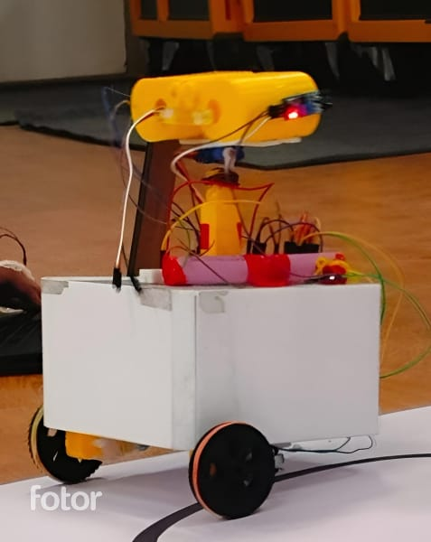

GROUP MEMBERS:

* VARAD PENDSE (230003084)
* VARIKUTI REETHIKA PRASANNA (230003085)
* VEDANSH SHRIVASTAVA (230003086)
* VANGALAPUDI ABHITHA (230003081)
* VANKA ABHINAYA SRI (230003082)
* VANSHIKA AGRAWAL (230003083)

INTRODUCTION TO THE PROJECT:

A line follower is a robotic system crafted to trail a visible line or pathway on the ground. Its core purpose lies in detecting and tracing the line's course, enabling it to traverse along the designated path. Drawing inspiration from Disney Pixar's character WALL-E, the fundamental design of this model incorporates sensors embedded in its eyes for gesture control. Additionally, we employed the Blynk app as a means to manipulate and direct the robot's movements.

EQUIPMENT REQUIRED:

1. IR SENSOR
2. ARDUINO UNO
3. MOTOR DRIVER
4. GEAR MOTOR
5. JUMPER WIRES
6. BATTERY HOLDER
7. WHEELS
8. LITHIUM BATTERIES
9. WIFI MODULE
10. ULTRA SONIC SENSORS

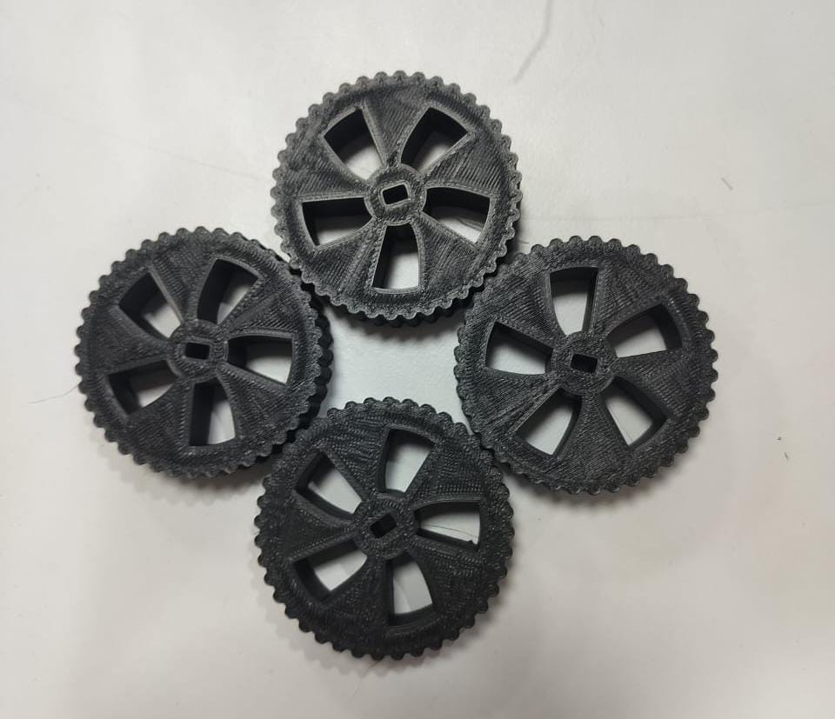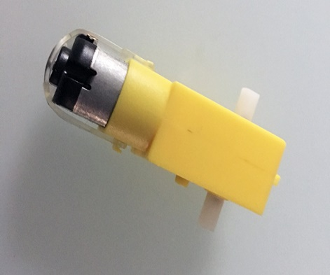

COMPONENTS DRAWINGS:

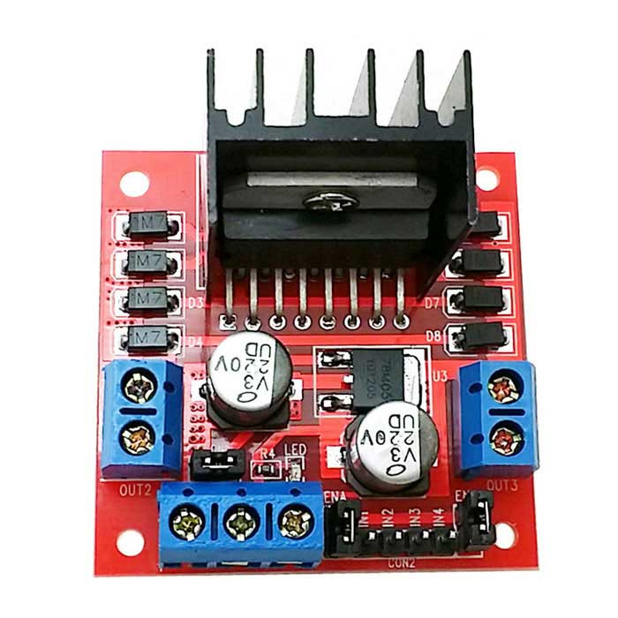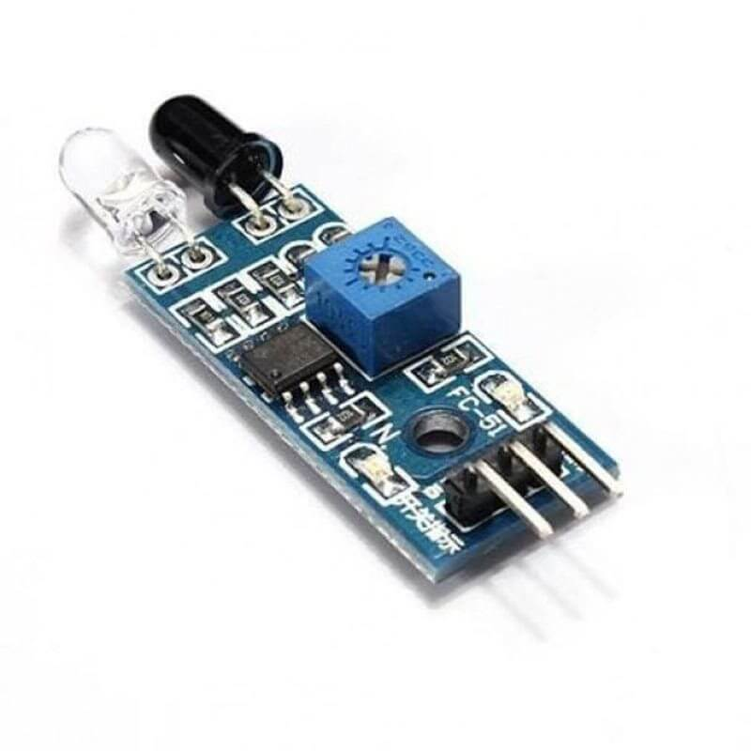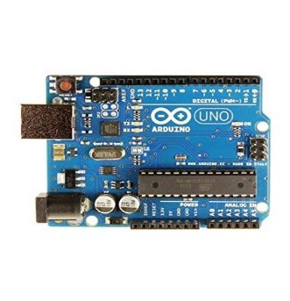

PROCEDURE IN EXECUTING THE PROJECT:

* Designing Chassis and body in Fusion 360 and getting it laser cut.
* Designing eyes neck and wheels in fusion 360 and getting it 3D printed.
* Attach the motors and wheels to the chassis
* Mount the IR sensors on the front of the robot, facing the ground. Ensure they are spaced apart and close to the ground to detect the line.
* Connect the motor leads and Arduino digital pins to the motor driver. The motor driver will allow you to control the direction and speed of each motor.
* Connect the output pins of the IR sensors to the input pins of the Arduino. Most IR sensors have a digital output that goes high when the sensor detects a line.
* Write a simple program to read the sensor inputs and control the motors. The basic logic involves:
* If both sensors are on the line or off the line, move forward.
* If the left sensor is off the line, turn right.
* If the right sensor is off the line, turn left.

VIDEO CLIPS OF THE LINE FOLLOWER:



VIDEO 1



VIDEO 2

KEY LEARNINGS FROM THE PROJECT:

We gained insights into how the physical dimensions of a robot significantly influence its mobility and overall effectiveness. This understanding was enhanced through hands-on experiences in designing wheels and chassis boards, utilizing machinery like 3D printers and laser cutters. Additionally, we delved into the realm of electronic components such as Arduino, Motor Drivers, and IR Sensors, deepening our comprehension of their functionalities and the involved connections. As a collaborative team effort, the project provided valuable lessons in teamwork and cooperation, enriching our collective experience.

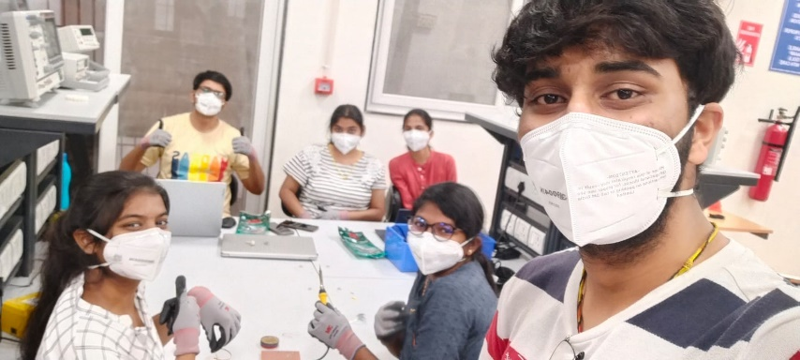

THANK YOU.